Welcome to mCheque Print

6 tips for a simpler way to use

User Manual

# Front screen

This is your Front screen of software.

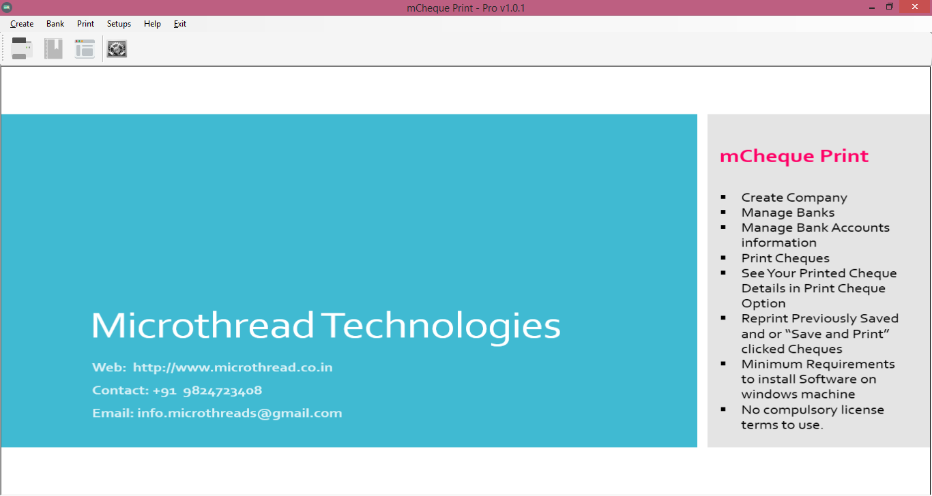

Now Follow Bellow Mention Instruction to prepare First Printed Cheque.

1. Go to Create >> Company (Or Direct Click on Company from Front Screen)

2. Enter your company and other details and save it.

3. Go to Bank >> Bank then click on search >> Again Search>> If your bank is not register in it click on Exit and Enter your Bank Name and Short code for this bank. Then save it.

4. Go to Bank >> Bank Account >>

a. Select your Bank

b. Select your company

c. Enter your bank account number or last four digit

d. Then fill other option for your reference or leave blank

e. Click on Save

5. Go to Bank >> Cheque Book >>

a. Select your Bank

b. Select account number

c. Select Layout (If it is not shown you need to make it.)

d. Enter your cheque series or 1 to 500 as testing.

e. Book name will make it automatically. But you can name as per requirements also.

f. Then Click on Save.

6. Go to Setup >> Printer Setup

a. Enter your printer name

b. For normal user select “Left to right” printing

c. Select “Set as Default Printer” if it is everyday printing printer.

d. Select “Set as Center Feeding” if it is “”Laser”” Printer.

e. Click On “Show Test Page” for demo cheques. Print it and use one of them and click on “Print Test Cheque”.

f. Click on “Set Margins (mm)”. If result is cheque details are moving upside enter mm in top. And if it is down side enter margin in mm in bottom and then test it. You may got perfect printer settings.Steps:

7. Now we are ready to Print First Cheque

a. Go to Print >> Cheque

b. Select Bank

c. Select Cheque Book

d. Select Payee or add pay just click on + button.

e. Enter amount

f. Cheque Number is auto selected. If you want to change you can change it.

g. Select date.

h. Select your printer type

i. Now Click on Save and Print

j. You First cheque Is printed.

8. If need any assistance you can email us on

[info.microthreads@gmail.com](mailto:info.microthreads@gmail.com)

# Cheque Layout

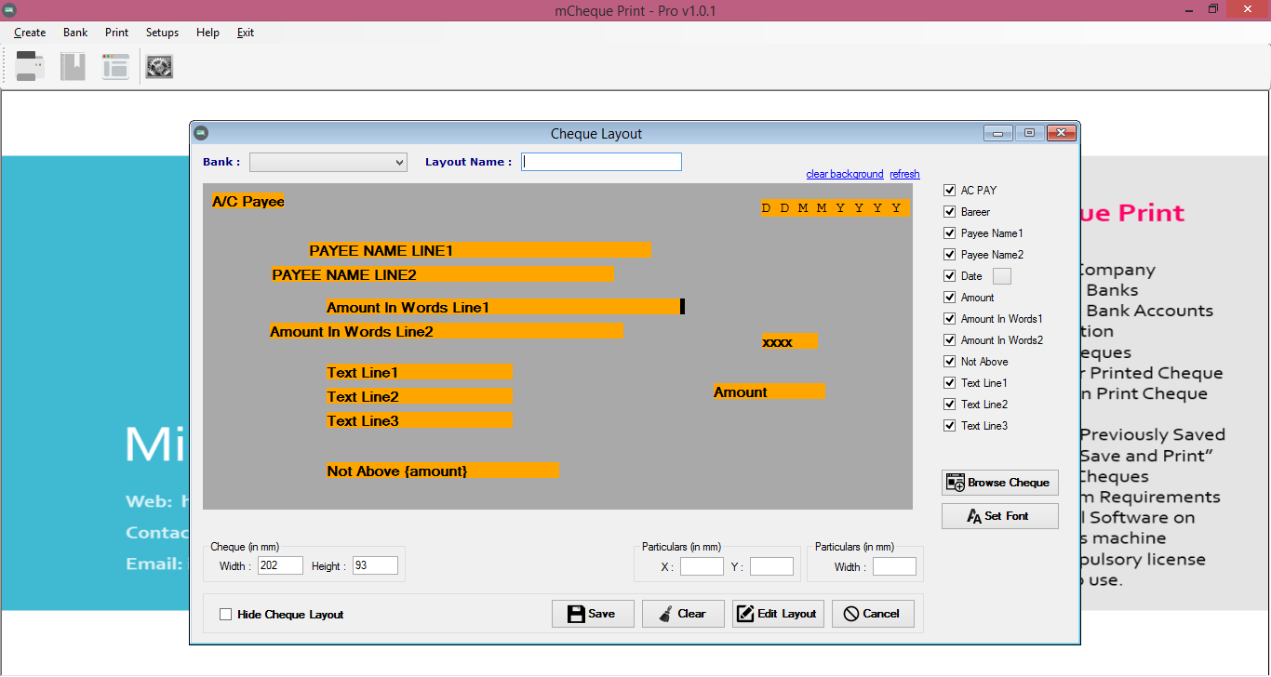

1. Cheque Layout

a. You can create cheque layout as per your requirements and/or for new non listed banks.

b. Go to Bank >> Cheque Layout >>

c. Select Bank Name

d. Enter your layout name

e. Click on “Browse cheque” and select your scan copy of cheque (Jpeg and PNG only).

f. Then enter your cheques original height and width of cheque in mm(millimeter)

g. Set Particulars as per your requirements and change fonts by clicking set fonts. You can deselect from right side menu whatever you not required.

h. Then save it to use your cheque books.

# Currency Setup

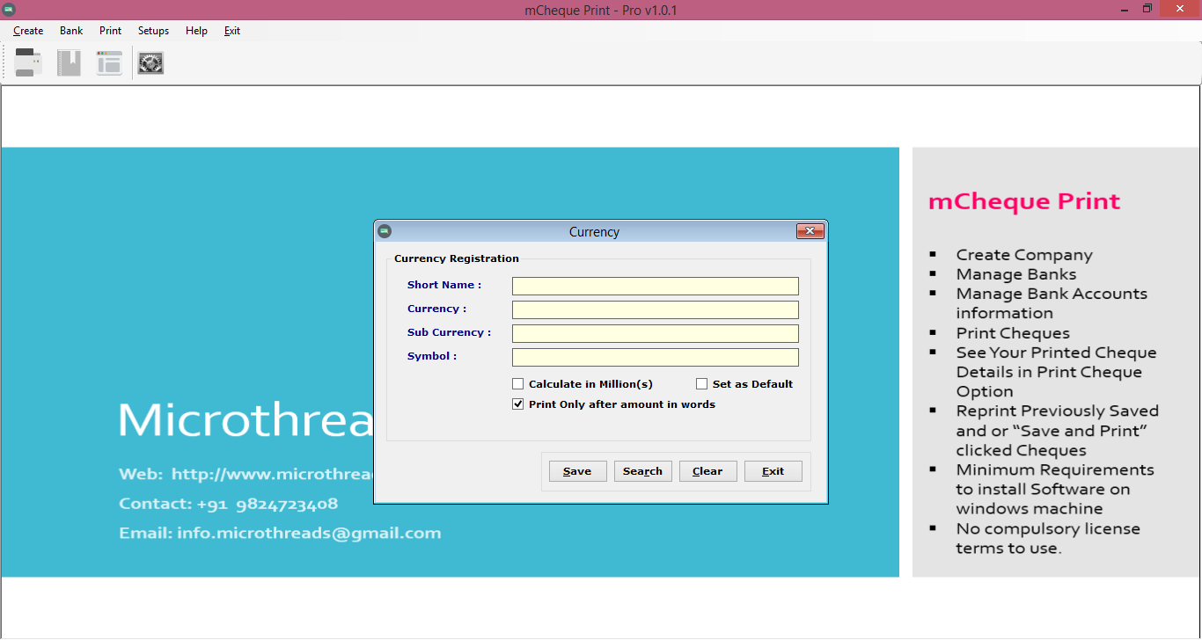

i. Go to Setup >> Currency Setup

j. Enter your Currency short Name Like for Indian Rupees “INR”.

k. Enter Base Currency name like for Indian Rupees “Rupee”

l. Enter Sub Currency name like for Indian Rupees “Paisa”

m. Enter symbol if your keyboard and computer is supported.

n. Default calculating method is Indian format in Lakhs.

o. You can calculate in millions select is.

p. If you want to print in daily use this currency “Set as Default”

q. Select If you want to print “Only” after amount in words.

r. Then Save it.

# General Support

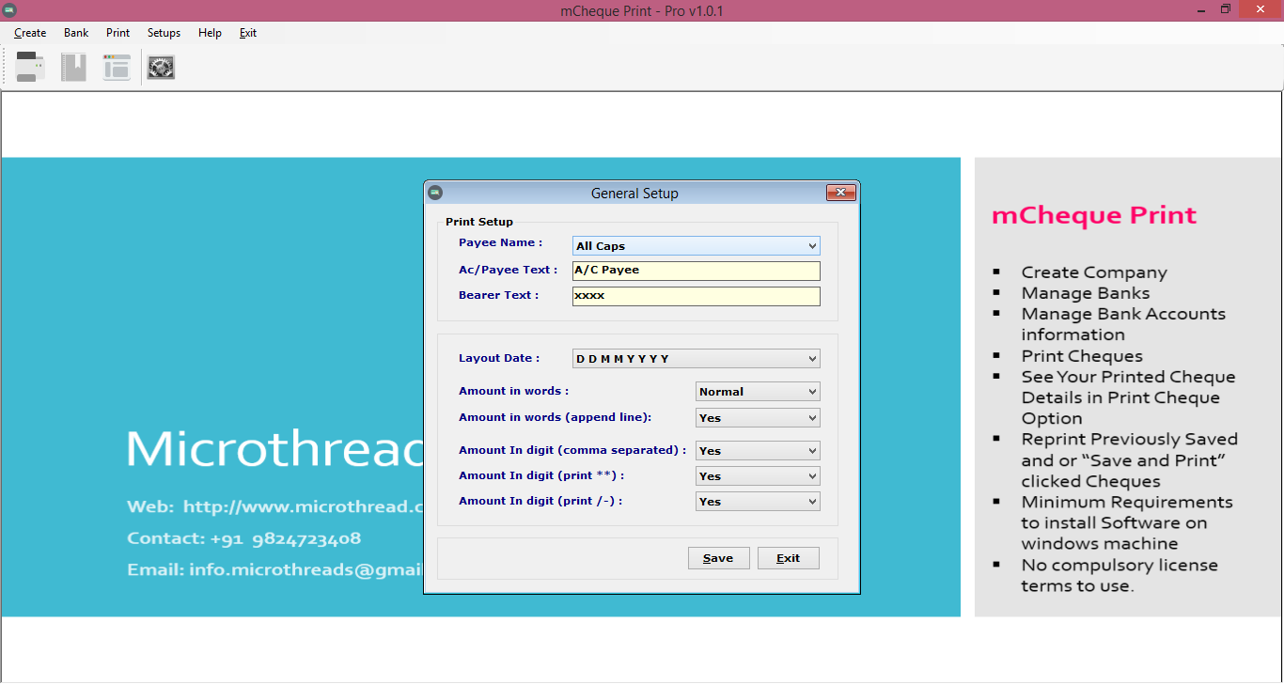

i. Payee Name : All caps /As you enter

ii. A/c Payee text: as you wants like (A/c Payee Only).

iii. Bearer text : As you want like(----)or (XXXX)

iv. Layout Date: Select default date format of your cheques.

v. Amount in words :- Normal/All Caps

vi. Amount in word Append Line: Yes/no (It is draw line in blank space of amount in word)

vii. Amount in digit(Comma separated) : Yes/No

viii. Amount in digit(print **): Yes/no

ix. Amount in digit(print /-):- Yes/no

x. Set your requirements and Save it.

# Special Printer Setup Guide

By click on print setup menu user can open print setup dialog which is shown like this.

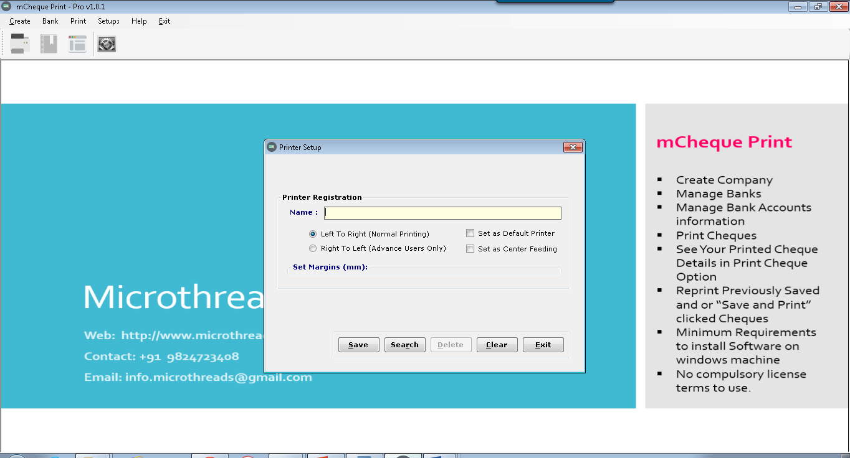

In this dialog user can setup printer name and its print position.

Steps:

1. Enter printer name.
2. Enter printing type.
   1. If you want to print left to right as per cheque writing. Select Left To Right.
   2. If you want to print Right to left as per cheque writing. Select Right to Left.
3. Set Margins (All parameters are in millimeter).
   1. LEFT means if you want to move margin from left to right of cheque.
   2. TOP means if you want to move margin from top to bottom of cheque.
   3. TOP means if you want to move margin from top to bottom of cheque.
   4. BOTTOM means if you want to move margin from bottom to top of cheque.
4. Check “Set as Default Printer” if you want to print regularly from this printer.
5. Check “Set as Center Feeding” if your printer if print from center.

# Other printer setup

Some Printer (Like Multi Function Inkjet Printers) cannot direct support small cheque size. So you need to enter cheque size in it.

1. For Windows XP Users

* Click start >> Control Panel
* Then go to “Printers and Faxes”
* Then Select your printer
* Then “ALT+F” or open FILE Menu
* Then Select “Server Properties”

Then You can Find Below Mentioned Window.

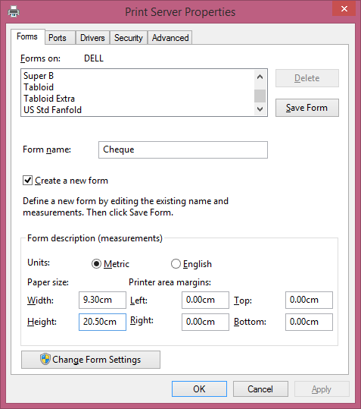

* Then Check on “Create a new Form”
* Enter Form Name as per you remember , Like “Cheque”
* In Units Check Metric
* In Paper size Width :- 9.30 Cm and Height 20.50 Cm
* Then Click on OK Button
* Then again select printer and right click and select properties then re enter cheque size details again if required.

1. For Windows 7/8/10 Users

* Click on Start >> Device and Printer
* Select your printer using Single Click
* Then Below Address bar you can find option “Print Server Properties”

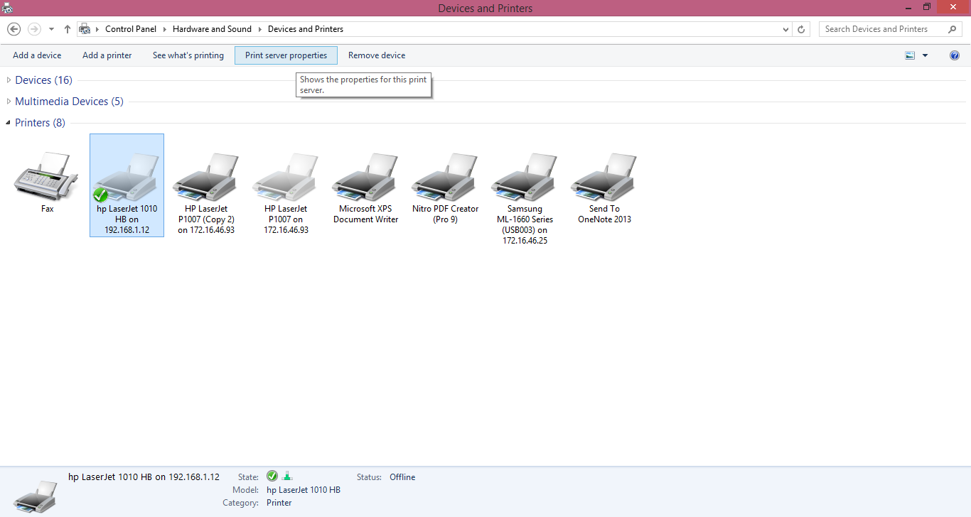

Then You can Find Below Mentioned Window



* Then Check on “Create a new Form”
* Enter Form Name as per you remember , Like “Cheque”
* In Units Check Metric
* In Paper size Width :- 9.30 Cm and Height 20.50 Cm
* Then Click on OK Button
* Then again select printer and right click and select properties then re enter cheque size details again if required.

**You can Contact us**

**Microthread Technologies**

**Ahmedabad – Surat**

**Gujarat, India**

**Web: www.microthread.co.in**

**Email: info.microthreads@gmail.com**

**Call for Purchase +91-9824723408**